1,

* How to check a variable’s type?

+ put the value into the variable i=17

+ find the type: type (i)

+ result comes out: <class ‘int’>

* Cases that occur syntax error:

+ when you have invalid names:

Eg:

76trombones = "big parade"

SyntaxError: invalid syntax | Because: this name begins with a number

>>> more$ = 1000000

SyntaxError: invalid syntax | because this one includes an invalid symbol

>>> class = "Computer Science 101"

SyntaxError: invalid syntax | because this one include python keword

+ when you have mistake in putting variable & value in the wrong positions

Eg: 17 = n => syntax error

2, Write a program that calculates the area of a circle: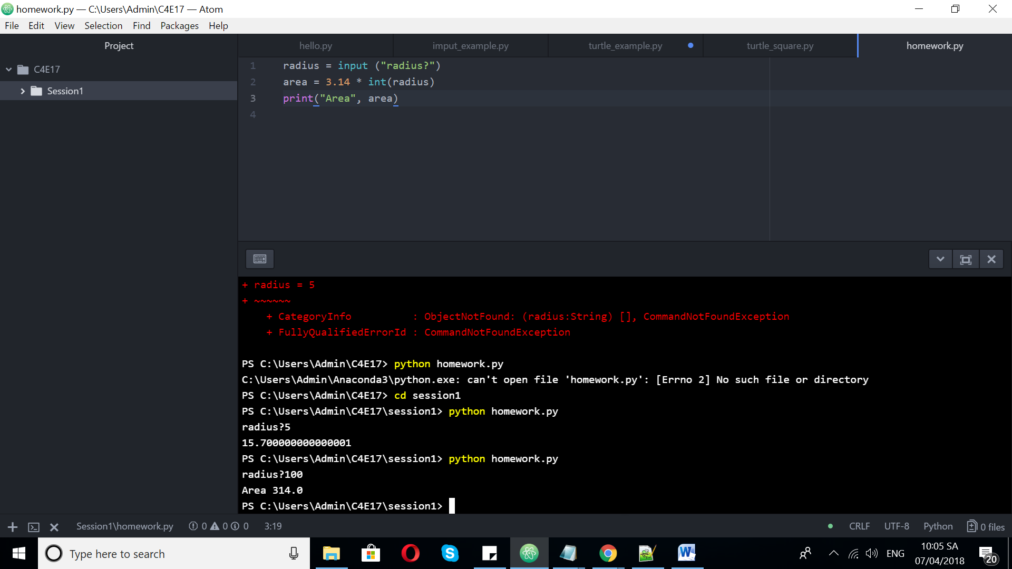

3, Write a program that converts Celsius (0C) into Fahrenheit (0F)

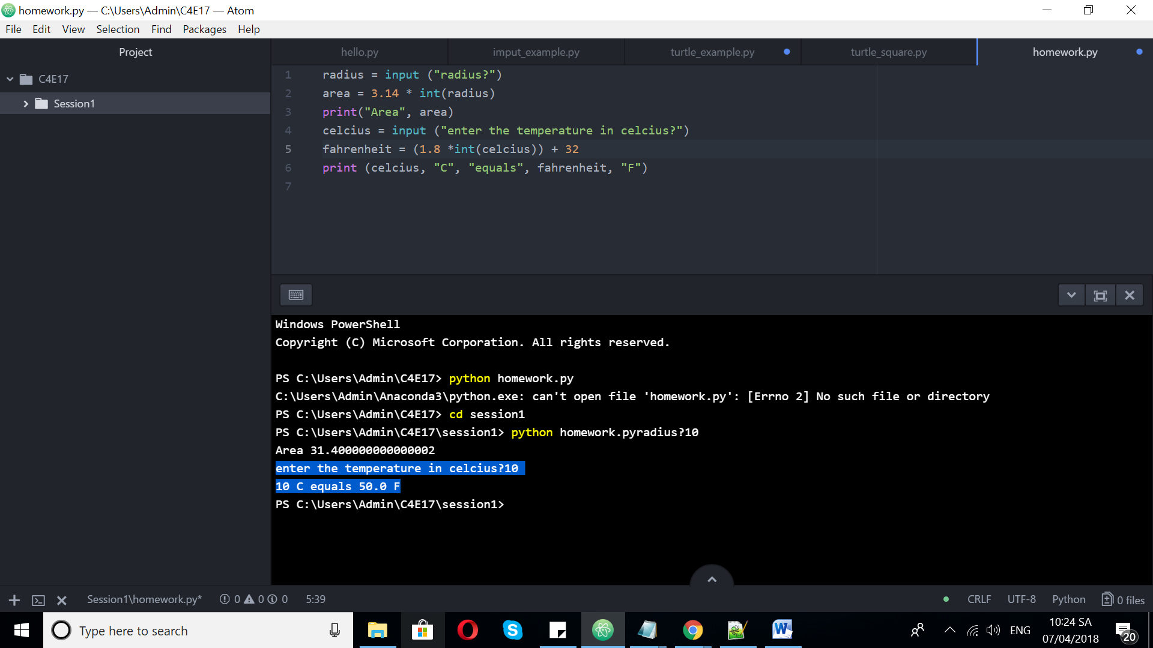

4, Turtle game

A, Square:

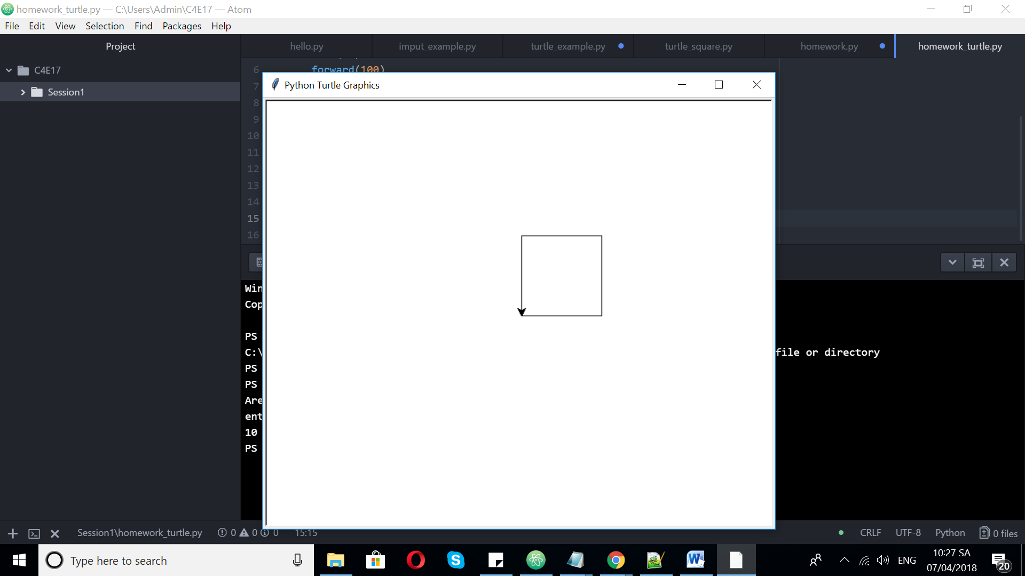

B, Triangle:

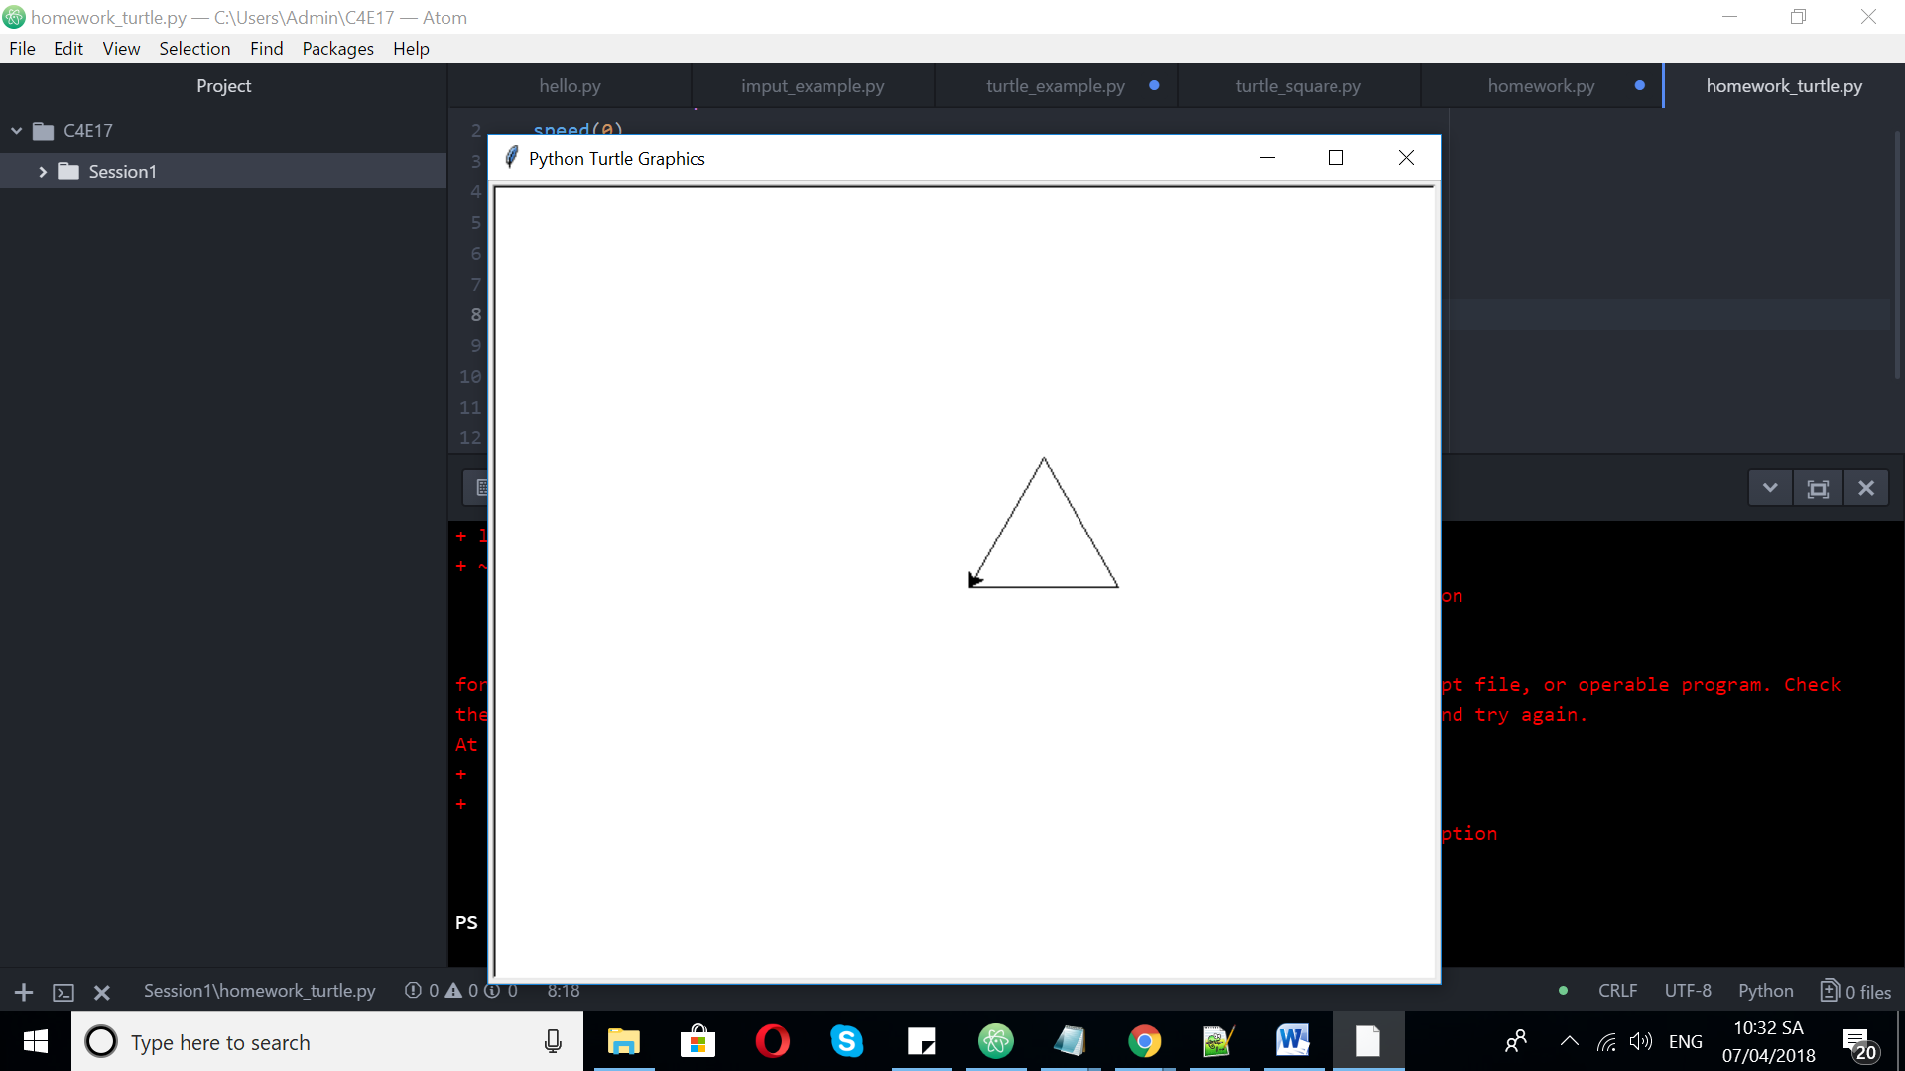

C, Circle:

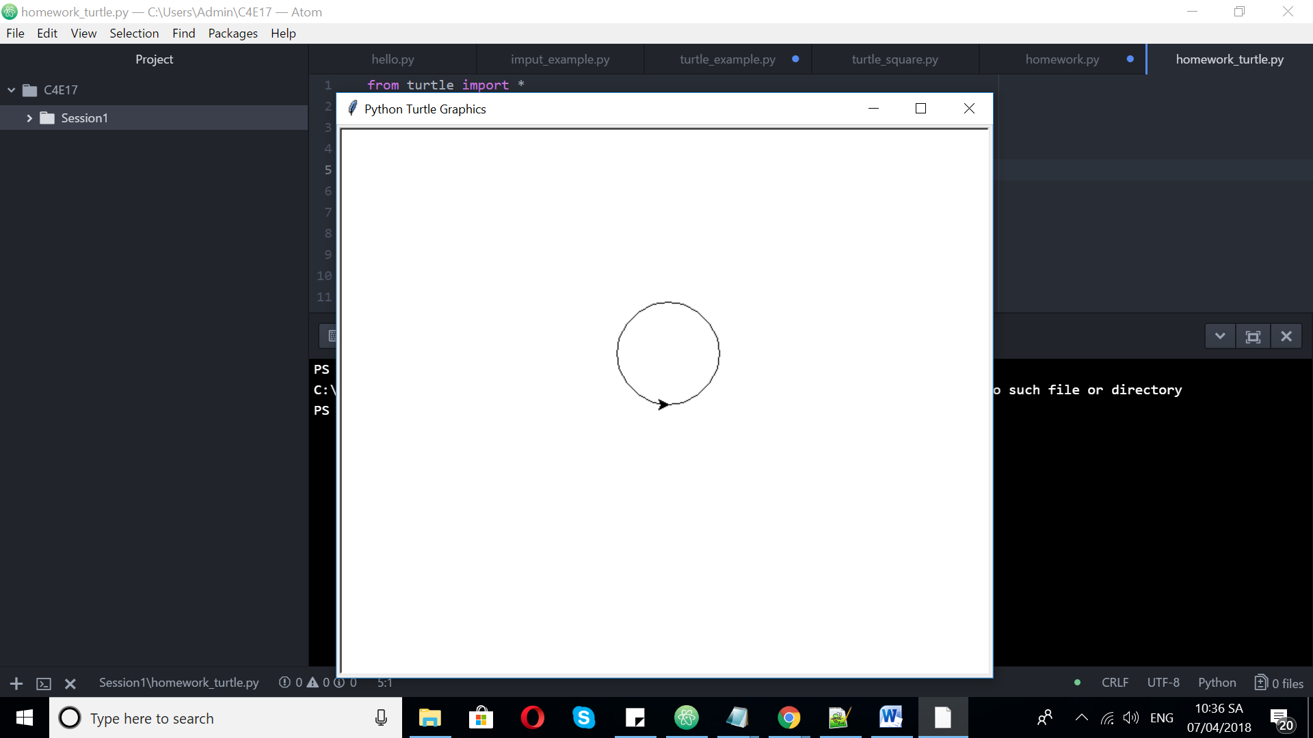

D, Multi circles:

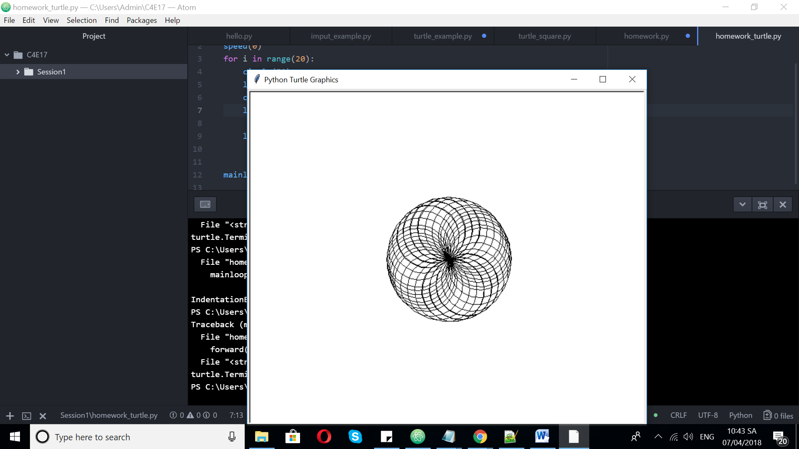

5, Sign up github

